|  |  |
| --- | --- |
| **Your Name:** Enter your name | **Date:** Click down arrow to select. |

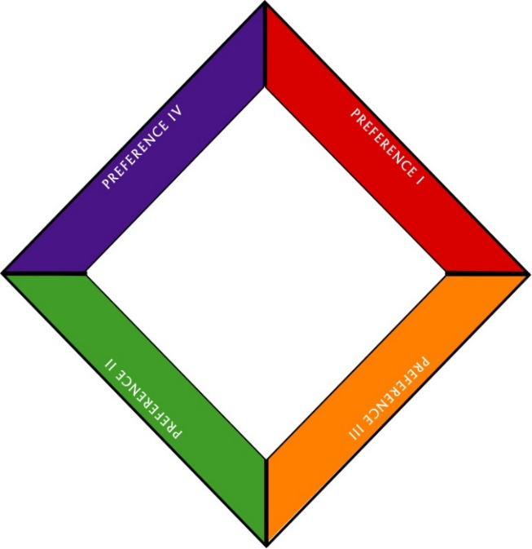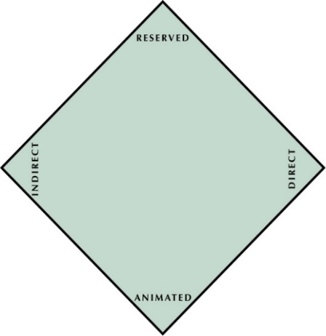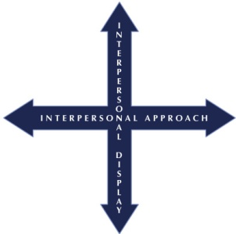

ANALYTICAL

EXPRESSIVE

DRIVING

AMIABLE

|  |  |  |
| --- | --- | --- |
| **ANALYTICAL** |  | **DRIVING** |
| Focus: Accuracy | Focus: Results |
| Tendency: Thinking | Tendency: Action |
| Blind Spot: Analysis Paralysis | Blind Spot: Lack of Listening |

|  |  |  |
| --- | --- | --- |
| **AMIABLE** |  | **EXPRESSIVE** |
| Focus: People & Support | Focus: Ideas & Endorsements |
| Tendency: Relationship Building | Tendency: Spontaneity |
| Blind Spot: Not Speaking Up | Blind Spot: Impulse Control |

|  |  |
| --- | --- |
| **1. Action Planning: Stop ● Keep ● Start** | **2. Conversation Background** |
| 1. **Stop**: Type what you will stop doing. 2. **Keep:** Type what you will keep doing. 3. **Start:** Type what you will start doing. | **Who:** Type person’s name.  **Purpose of Conversation:** Enter purpose here.  **Person’s Probable Style**: Click down arrow to select.  **Person’s Style-based Strengths:** Enter strengths.  **Person’s Blind Spot:** Click down arrow to select.  **Which Interpersonal Approach do you share, if any?** Click down arrow to select.  **Which Interpersonal Display do you share, if any?** Click down arrow to select. |
| **3. Conversation Planning** | **4. Post-Conversation Insights** |
| 1. **How will you adapt your behavior for this person?** Type how you will adapt. 2. **What is your best use of time for this person?** Click down arrow to select. 3. **What impact could your Style have on this interaction?** Type how your Style will impact. | 1. **What worked?** Enter what worked. 2. **What didn’t work?** Enter what didn’t work. 3. **What will you do differently next time?** Enter what you’ll do differently. 4. **What do you need to learn more about?** Enter what you’ll learn more about. |